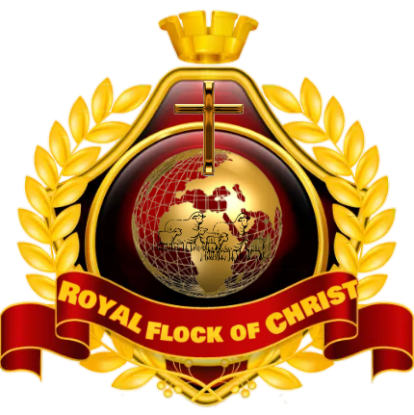 Royal Flock of Christ
Children Church Monthly Sermon Outline
December 2022

Week1: Sunday 4, Prayer
- What is Prayer?
Prayer means talking to God
- Why we pray.
We pray to thank God and ask something from him.
Bible reading: Matthew 6:9-13
Bible story

Week 2: Sunday 11, Prayer
- How to pray
Pray with your eyes closed
Pray in the name of Jesus
Bible reading John 14:13-14
Bible story

Week 3 Sunday 18 Prayer
- When to pray
Pray at night before going to bed
Pray before eating any meal
Bible reading Act 27:33-35
Bible story

Week 4 Sunday 25 Prayer
- Pray always
- Pray for others
Bible reading Act 12:1-12
Bible story

